資料庫管理系統

期末專題報告

系級:資訊碩一

姓名:蘇奕瑋

學號:P76081108

* 報告主題

實作經銷商產品訂單銷售系統

* 需求描述
* Entity

Entity1:經銷商公司會有客戶資料customer

客戶資料attribute包含如下

1. 客戶代號(Key attribute): custID
2. 客戶姓名:custName
3. 客戶電話:custPhone
4. 客戶地址:custAddr

故其ER Diagram :

customer

Entity2:經銷商公司會有員工資料employee

員工資料attribute包含如下

1. 員工代號(Key attribute): EmpID
2. 員工姓名:EmpName
3. 員工電話:EmpPhone

故其ER Diagram :

employee

Entity3:訂單資料order

訂單資料attribute包含如下

1. 訂單編號(Key attribute): orderID
2. 運費:fare
3. 送貨日期:deliverDate

故其ER Diagram :

order

Entity4:產品資料product

產品資料attribute包含如下

1. 產品代號(Key attribute): productID
2. 定價:price
3. 產品名稱:productName

故其ER Diagram :

product

Entity5:供應商資料vender

供應商資料attribute包含如下

1. 供應商代號(Key attribute): venderID
2. 供應商名稱:venderName
3. 供應商電話:venderPhone
4. 供應商地址:venderAddr

故其ER Diagram :

vender

* Relationship

1. 客戶-員工-訂單存在”訂購”(purchase)的三元關係

針對一個客戶會配給一個員工處理訂購業務,訂購可以訂購多個訂單.

ER diagram :

purchase

order

employee

customer

1

1

N

1. 訂單-產品之間存在”包含”(include)的二元關係

其中還要記錄產品數量(Iquantity)

ER diagram :

include

product

order

1

N

1. 供應商-產品之間存在”供應”(provide)的二元關係

其中還要記錄供應的產品數量(Pquantity)

ER diagram :

provide

product

vender

1

N

* 完整ER Model

N

1

customer

purchase

1

employee

order

include

product

1

N

provide

vender

1

N

* ER Schema

Entity

1. customer

|  |  |  |  |
| --- | --- | --- | --- |
| custID | custName | custPhone | custAddr |

1. employee

|  |  |  |
| --- | --- | --- |
| EmpID | EmpName | EmpPhone |

1. order

|  |  |  |
| --- | --- | --- |
| orderID | fare | deliverDate |

1. product

|  |  |  |  |  |  |  |
| --- | --- | --- | --- | --- | --- | --- |
| productID | productName | price | orderID | Iquantity | venderID | Pquantity |

include關係 provide關係

1. vender

|  |  |  |
| --- | --- | --- |
| venderID | venderName | venderPhone |

1. purchase關係

purchase

|  |  |  |
| --- | --- | --- |
| custID | EmpID | orderID |

custID/orderID合起來作為複合主鍵

同時三個欄位都為外來鍵

* 程式實作

採用C# 和 Visual Studio的Local database實作

[Note] : 完整程式碼於以下github連結:

<https://github.com/Wilson50101/DBMS_Final_Project>

* 資料表定義以及初始資料設定:

//customer資料表

CREATE TABLE [dbo].[customer] (

[custID] NVARCHAR (50) NOT NULL,

[custName] NVARCHAR (50) NOT NULL,

[custPhone] NVARCHAR (50) NULL,

[custAddr] NVARCHAR (50) NOT NULL,

PRIMARY KEY CLUSTERED ([custID] ASC)

);

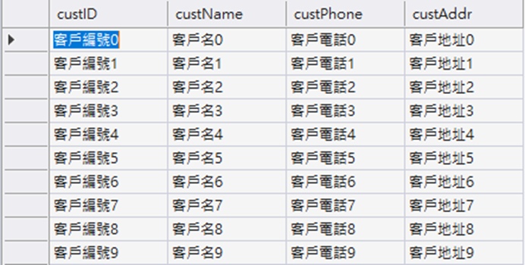

//employee資料表

CREATE TABLE [dbo].[employee] (

[EmpID] NVARCHAR (50) NOT NULL,

[EmpName] NVARCHAR (50) NOT NULL,

[EmpPhone] NVARCHAR (50) NULL,

PRIMARY KEY CLUSTERED ([EmpID] ASC)

);

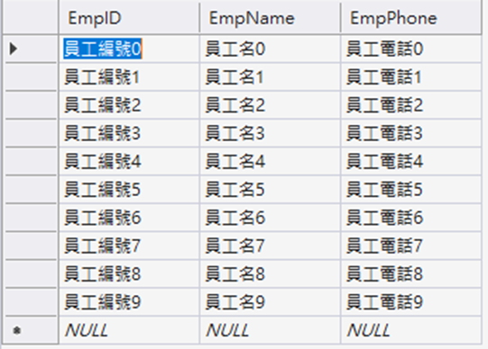

//orders資料表

CREATE TABLE [dbo].[orders] (

[orderID] NVARCHAR (50) NOT NULL,

[fare] INT NOT NULL,

[deliverDate] NVARCHAR (50) NOT NULL,

PRIMARY KEY CLUSTERED ([orderID] ASC)

);

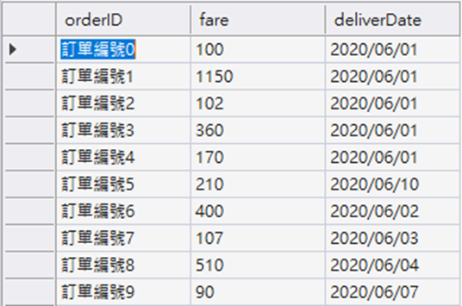

//product資料表

CREATE TABLE [dbo].[product] (

[productID] NVARCHAR (50) NOT NULL,

[productName] NVARCHAR (50) NOT NULL,

[price] INT NOT NULL,

[orderID] NVARCHAR (50) NULL,

[Iquantity] INT NULL,

[venderID] NVARCHAR (50) NULL,

[Pquantity] INT NULL,

PRIMARY KEY CLUSTERED ([productID] ASC),

CONSTRAINT [FK_product_orders] FOREIGN KEY ([orderID]) REFERENCES [dbo].[orders] ([orderID]) ON DELETE CASCADE,

CONSTRAINT [FK_product_vender] FOREIGN KEY ([venderID]) REFERENCES [dbo].[vender] ([venderID]) ON DELETE CASCADE

);

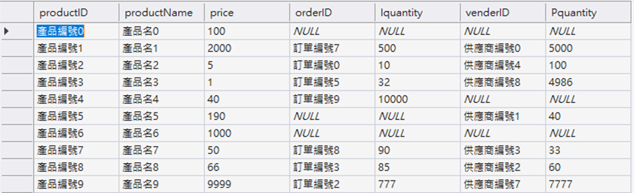

//purchase資料表

CREATE TABLE [dbo].[purchase] (

[custID] NVARCHAR (50) NOT NULL,

[EmpID] NVARCHAR (50) NOT NULL,

[orderID] NVARCHAR (50) NOT NULL,

PRIMARY KEY CLUSTERED ([custID] ASC, [orderID] ASC),

CONSTRAINT [FK_purchase_customer] FOREIGN KEY ([custID]) REFERENCES [dbo].[customer] ([custID]) ON DELETE CASCADE,

CONSTRAINT [FK_purchase_employee] FOREIGN KEY ([EmpID]) REFERENCES [dbo].[employee] ([EmpID]) ON DELETE CASCADE,

CONSTRAINT [FK_purchase_orders] FOREIGN KEY ([orderID]) REFERENCES [dbo].[orders] ([orderID]) ON DELETE CASCADE

);

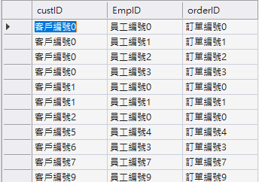

//vender資料表

CREATE TABLE [dbo].[vender] (

[venderID] NVARCHAR (50) NOT NULL,

[venderName] NVARCHAR (50) NOT NULL,

[venderPhone] NVARCHAR (50) NULL,

PRIMARY KEY CLUSTERED ([venderID] ASC)

);

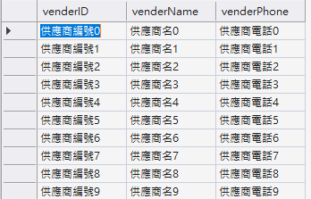

* 程式操作介面:

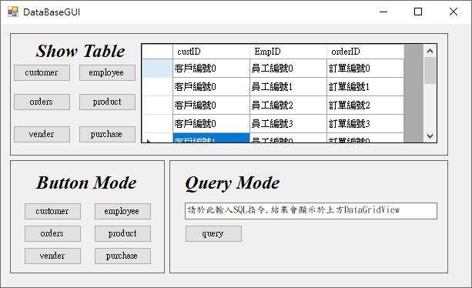

**4**

**1**

**2**

**3**

1 : 選取要show何種資料表內容在2的DataGridView上面

2 : DataGridView用來呈現要顯示的資料

3 : 按鈕模式來對資料庫做操作

4 : 指令模式直接下SQL

//按鈕模式(以product為例)

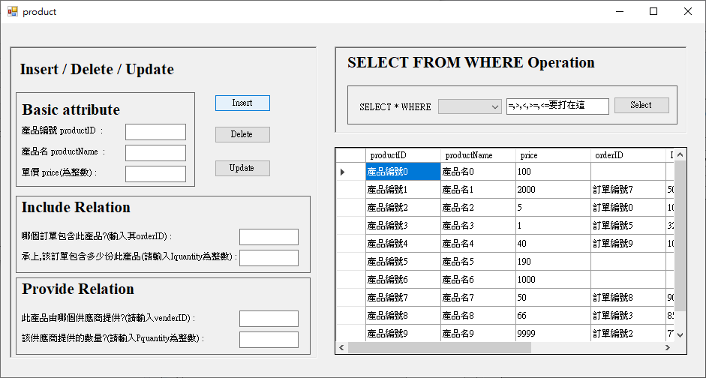

**2**

**1**

1. 在每個Textbox輸入對應之欄位的資料後按下要做的指令

然後選擇要執行Insert/Delete/Update指令

1. 在combo_box選擇比較條件欄位,然後在Textbox輸入條件細節,在按下select執行搜尋

然後都會在DataGridView呈現結果